**A PROJECT REPORT**

**On**

**Image Classification using CNN**

**Submitted to**

**KIIT Deemed to be University**

**In Partial Fulfillment of the Requirement for the Award of BACHELOR’S DEGREE IN**

**INFORMATION TECHNOLOGY**

**Shivanshu Krishna Gupta(2106255)**

**Som Prakash Sahu(2106258) Aryan(2106193)**

**Aryan Chourasia(2106194)**

**UNDER THE GUIDANCE OF**

**Mr. Pushkar Kishor**



**SCHOOL OF COMPUTER ENGINEERING KALINGA INSTITUTE OF INDUSTRIAL TECHNOLOGY**

**BHUBANESWAR, ODISHA - 751024**

KIIT Deemed to be University

School of Computer Engineering Bhubaneswar, ODISHA 751024



# CERTIFICATE

This is certify that the project entitled

“**Image Classification using CNN**”

submitted by :

Shivanshu Krishna Gupta(2106255)

Som Prakash Sahu(2106258) Aryan(2106193)

Aryan Chourasia(2106194)

is a record of Bonafide work carried out by them, in the partial fulfillment of the requirement for the award of Degree of Bachelor of Engineering (Computer Science & Engineering OR Information Technology) at KIIT Deemed to be university, Bhubaneswar. This work is done during the year 2024-2025, under our guidance.

Date: / /

(Guide Name)

Mr. Pushkar Kishor

## Acknowledgements

We are profoundly grateful to **Mr. Pushkar Kishor**

of CSE for his expert guidance and continuous encouragement throughout to see that this project rights its target from its commencement to its completion.

Shivanshu Krishna Gupta(2106255) Som Prakash Sahu(2106258)

Aryan (2106193)

Aryan Chourasia(2106194)

## ABSTRACT

This project investigates the training, interoperability, and development of a deep learning image classification model based on Convolutional Neural Networks (CNNs). The model is trained on the CIFAR-10 dataset, which comprises 60,000 images representing 10 classes, to automatically identify and classify objects. Several preprocessing methods, including data normalization and class balancing, are used to increase training efficiency and model performance.

One of the central features of this project is enhancing interoperability. As deep learning models are essentially "black boxes," we use Grad-CAM (Gradient-weighted Class Activation Mapping) to see which areas of an image affect the decisions of the model. This facilitates understanding how the network learns and provides transparency to decision- making. A layer-wise performance analysis is also performed, assessing the feature extraction ability of various layers of the network. Per-class threshold tuning is also used to improve classification precision by optimizing precision-recall trade-offs.

By integrating model training, evaluation, and explainability, this project sheds light on how to improve CNN-based image classification and make AI systems more interpretable and reliable. The methodology can be applied to other fields, such as medical imaging, security surveillance, and autonomous systems, where accuracy and interpretability are important.

# Contents

|  |  |  |  |
| --- | --- | --- | --- |
| **S.No.** | **Chapter** | **Title** | **Page No.** |
| 1 | Chapter 1 | Introduction | 1 |
| 2 | Chapter 2 | Basic Concepts/Literature Review | 2 |
| 2.1 |  | Subsection: Convolutional Neural Networks (CNNs) | 2 |
| 2.2 |  | Subsection: CIFAR-10 Dataset | 2 |
| 2.3 |  | Subsection: Data Preprocessing Techniques | 2 |
| 2.4 |  | Subsection: Class Imbalance and Weighting | 2 |
| 2.5 |  | Subsection: Model Architecture (Layers and Activation Functions) | 3 |
| 2.6 |  | Subsection: Optimization Techniques | 3 |
| 2.7 |  | Subsection: Performance Metrics | 3 |
| 2.8 |  | Subsection: Grad-CAM for Model Interoperability | 3 |
| 2.9 |  | Subsection: Threshold Tuning for Classification | 3 |
| 3 | Chapter 3 | Problem Statement/Requirement Specifications | 4 |
| 3.1 |  | Project Goals | 4 |
| 3.2 |  | Project Analysis | 5 |
| 3.3 |  | System Design | 6 |
| 4 | Chapter 4 | Implementation | 7 |
| 4.1 |  | Methodology/Proposal | 7 |
| 4.2 |  | Testing/Verification Plan | 8 |
| 4.3 |  | Result Analysis/Screenshots | 9-10 |
| 4.4 |  | Model Validation and Interoperability | 10-11 |
| 5 | Chapter 5 | Standards Adopted | 12 |
| 5.1 |  | Design Standards | 12 |
| 5.2 |  | Coding Standards | 13 |
| 5.3 |  | Testing Standards | 14 |
| 6 | Chapter 6 | Conclusion and Future Scope | 15 |
| 6.1 |  | Conclusion | 16 |
| 6.2 |  | Future Scope | 17 |

Introduction

Here, we create a Convolutional Neural Network (CNN) that can automatically identify and classify images. CNNs are deep learning models that are particularly good at processing visual data since they are constructed to extract patterns, textures, and shapes from images using several layers of processing.

The project employs the popular CIFAR-10 dataset, which comprises 60,000 colored images spread across 10 various classes like airplanes, cars, and birds. Through training the CNN on this dataset, the model is able to differentiate between various objects by extracting significant features from the images automatically.

An important objective of our project is to not only get high classification accuracy but also to make the decision-making process of the model understandable. We accomplish this by using Grad-CAM (Gradient-weighted Class Activation Mapping), a method that, by visualizing, marks the regions of an image where the model attends during its prediction.

This explainability allows us to see why the CNN is making certain predictions about images and ensures that it makes decisions on the basis of relevant visual features.

In total, this project illustrates how CNNs can be used to tackle real-world image classification problems, giving both correct predictions and insights into the inner workings of the model. The outcomes can be used as a foundation for building more sophisticated and explainable AI systems for use in a variety of applications, including healthcare, autonomous systems, and more.

#### Importance of the Project

This project is important as it illustrates the ability of Convolutional Neural Networks (CNNs) in image classification automation, a core task in artificial intelligence. Through training the model using the CIFAR-10 dataset, we highlight how deep learning can effectively identify patterns and objects and therefore use it in diverse real-life applications like medical imaging, autonomous vehicles, and surveillance security. Second, the incorporation of Grad-CAM for model explainability increases transparency, enabling us to see the decision-making processes of the network. This is essential in order to establish confidence in AI models, particularly for applications that have serious implications such as in clinical or financial cases where model interpretations are required. The project, apart from boosting image classification precision, also reinforces the importance of explainable AI, making deep learning more robust and accessible to future advancements.

# Chapter 2

**Basic Concepts/ Literature Review**

The section gives an overview of the theoretical concepts and existing work on which the project is based. It discusses the theory behind deep learning, in particular, image classification methods, and summarizes the development and use of convolutional neural networks (CNNs) in computer vision. The review of literature explains major advancements, compares some of the prominent architectures, and explains how methods of explainability have evolved to provide insights into model behavior. This foundation lays the groundwork for comprehending the following design decisions and implementation approaches employed in the project.

###### CNN

Convolutional Neural Networks (CNNs) are a class of deep learning models particularly effective for processing grid- like data such as images. They consist of layers that perform convolution operations, which apply filters to input images to extract features like edges, textures, and shapes. These networks also typically include pooling layers that reduce spatial dimensions, allowing for translation invariance and reducing computational load. CNNs have been extensively researched and successfully applied in various fields, including object recognition, medical imaging, and autonomous vehicles. Their ability to learn hierarchical representations—starting from low-level features in early layers to high-level concepts in deeper layers—makes them a natural choice for image classification tasks.

* 1. **CIFAR-10 Dataset**

The CIFAR-10 dataset is a commonly used benchmark in computer vision. The dataset consists of 60,000 32×32 color images in 10 classes (airplanes, automobiles, birds, cats, etc.) with 50,000 training images and 10,000 test images. The CIFAR-10 dataset is a small (but lofty) benchmark used to evaluate image classification methods when the images have such diverse content but small size. CIFAR-10 is used by researchers to compare model performances and with datasets used as standard for image classification benchmarks, it is a realistic dataset that can be used for researchers exploring CNN architectures, and testing other preprocessing options, as well as as a benchmark that enables researchers to demonstrate increases in accuracies and generalization performance.

###### Data Preprocessing Techniques

###### Data preprocessing is a necessary procedure that takes raw images and prepares them for effective training of models. In this project, preprocessing consists of normalizing pixel values from a range of 0 to 255 to 0 to 1 by dividing them by 255. This normalization helps stabilize the training process and accelerates convergence. Also, images are resized or transformed to ensure the dimensions are consistent and data augmentation techniques are used to artificially expand the training dataset in the form of rotating, flipping, and zooming in on images. These techniques can aid in the model's generalizing capability as they simulate differing real-world conditions, and can also help prevent overfitting by exposing the model to a wider range of images for the model to learn from.

###### Class Imbalance and Weighting

###### Class imbalance arises when some classes in the dataset are under represented compared to other classes. This can result in biased model performance overly influenced by majority classes. Strategies such as calculating class weights can help minimize any bias. Class weights change the penalty in the loss function by incurring a higher penalty when the model misclassifies under-represented classes. This strategy helps direct more attention to the minority classes, resulting in a more equal and robust performance of the model. With CIFAR-10, although the dataset is relatively balanced, there are still times when the same strategies are justified with other datasets or imbalances are created when sampling data subsets.

###### Model Architecture (Layers and Activation Functions)

###### The architecture of the model used for this project employs a convolutional neural network (CNN) made up of multiple layers to extract and process features from images. The model architecture consists of several convolutional layers using small filters to learn local patterns, along with pooling layers that downsample the spatial dimension and act as a tool for reducing overfitting. It also consists of fully connected (dense) layers that use the features extracted by previous layers to perform the final classification. After each convolutional layer, activation functions, such as ReLU (Rectified Linear Units), are implemented for non-linearity in order for the model to jointly learn to represent complex representations. The model also adopts dropout layers to aid in overcoming overfitting during the training process by randomly deactivating an amount of neurons in training, to improve the networks' ability to generalize to data it has not seen before.

###### Optimization Techniques

###### Models utilize optimization methods to modify the parameters of the model to minimize the loss function as training progresses. In projects like this, we utilize Adam, or one of its variants (e.g., Adamax), since they are well-suited for sparse gradients and can adjust the learning rate automatically. In addition to improving training speed, which can produce better models more rapidly, we've included learning rate scheduling, early stopping, and batch normalization as additional features to the training process. Learning rate scheduling privileges the weight updates done by the model (as training progresses) to adjust appropriately to training progress. Early stopping prevents overfitting, as training will stop when the accuracy on its validation set sees diminishing returns.

###### Performance Metrics

###### Assessing the performance of a CNN involves many metrics that together provide a well-rounded understanding of model accuracy and reliability. Metrics that are often used include overall accuracy, which measures how many of the images are classified correctly; precision and recall, which measure the accuracy of positive predictions and how many of the available predictions fall into this relevant population; and the F1-score, which is a summary metric of precision and recall put into one number. Look also to other tools for evaluation, such as the confusion matrix, which will provide an in-depth look at how classes are predicted; and Receiver Operating Characteristic (ROC) curves and Area Under the Curve (AUC), which measure the ability of the model to separate or distinguish between classes across threshold levels.

###### Grad-CAM for Model Interpretability

###### Grad-CAM (Gradient-weighted Class Activation Mapping) is a framework for interpretability that provides insights about sections of an input image that were most useful for a decision made by the model. By taking the gradients of the predicted class score with respect to the feature maps of the final convolutional layer, Grad-CAM can produce a heatmap showing the important locations of the image in making the decision. The use of visual explanations can clarify the inner workings of the CNN, confirming that the model is focusing on the right sections, and can help developers and end-users trust the system's decisions. Grad-CAM is particularly important in sensitive cases such as in medical imaging, where the reason for a model's decision is essential.

###### Threshold Tuning for Classification

###### Threshold tuning refers to a technique to improve the decision boundary when attempting to classify output. Specific models will set a default threshold –typically, for binary classification, the default is 0.5- to classify predicted output based on the probability generated by the model. A default threshold is unlikely to give the most favorable balance of precision and recall, given the many conditions (most significantly, class imbalance or misclassification costs) that can impact a model's predictions. Through the application of threshold tuning, the model can be sensitive to an imbalance in classes and improve performance overall. As part of this project, we will investigate the opportunities to fine-tune the mean-resolution threshold applied to the classification output, to ensure that predictions are as accurate and balanced as possible, and to improve the reliability of the Grad-CAM visualizations when making inferences from model decisions overall.

###### Chapter 3

**Problem Statement/Requirement Specifications**

In the realm of computer vision, image classification is a pivotal task with applications ranging from autonomous vehicles and security systems to medical imaging. Despite significant advancements in deep learning, accurately classifying images remains a challenge due to issues such as high dimensionality of visual data, limited diversity in training datasets, and the “black box” nature of Convolutional Neural

Networks (CNNs). These models often deliver impressive accuracy but do so without providing insights into their decision-making process. This lack of transparency is a major hurdle in sensitive applications like healthcare, where understanding the basis for a prediction is as important as the prediction itself.

**Problem Statement:** Despite the success of Convolutional Neural Networks (CNNs) in image classification, challenges remain due to their "black box" nature and sensitivity to issues like class imbalance and overfitting. This project aims to develop a robust CNN that not only achieves high accuracy on datasets like CIFAR-10 but also integrates explainability methods (e.g., Grad-CAM and threshold tuning) to make its decision-making process transparent and trustworthy.

**Requirement Specifications (SRS):**

* **Data:** Preprocess CIFAR-10 (normalize, resize, augment, balance).
* **Model:** Build a CNN with convolution, pooling, dense layers, and dropout; train with an adaptive optimizer.
* **Evaluation:** Use accuracy, precision, recall, F1-score, and confusion matrix; validate robustly.
* **Interoperability:** Apply Grad-CAM and tune thresholds.
* **Design:** Modular and scalable architecture.
  1. **Project Goals**

###### Accurate Image Classification:

The primary goal is to develop a Convolutional Neural Network (CNN) that accurately classifies images from the CIFAR-10 dataset into 10 distinct categories. This involves training the model to recognize complex visual patterns and correctly label images such as airplanes, automobiles, birds, cats, and more.

###### Efficient Data Processing:

Ensure that the model processes the input data effectively through proper preprocessing techniques, including normalization, resizing, and augmentation. This will allow the network to learn robust features and generalize well on unseen data.

* **Enhanced Model Interpretability:**

Integrate explainability methods like Grad-CAM to generate visual explanations of the model’s decisions. This is critical for verifying that the CNN focuses on relevant image regions, thereby building trust in the model’s predictions.

###### Optimized Threshold Tuning:

Implement threshold tuning for classification outputs to optimize the balance between precision and recall. Adjusting decision thresholds ensures that the model maintains high accuracy, particularly in scenarios where the default threshold may lead to suboptimal performance.

###### Scalability and Adaptability:

Design the system architecture to be modular and scalable, enabling future enhancements such as applying the same techniques to larger datasets or adapting the model for different image classification tasks.

* 1. **Project Analysis**

###### Current Challenges in Image Classification:

Image classification is a well-researched area in computer vision, but several challenges persist. These include dealing with high-dimensional data, overfitting due to limited data variability, and ensuring the model’s predictions are both accurate and interpretable.

###### Dataset Characteristics and Limitations:

The CIFAR-10 dataset is widely used for benchmarking, but its small image size (32×32 pixels) and limited diversity can make feature extraction challenging. Moreover, even if CIFAR-10 is relatively balanced, real- world applications often face class imbalance, which necessitates methods like class weighting.

###### Need for Interoperability:

Deep learning models, particularly CNNs, are often criticized for their "black box" nature. Without clear insights into their decision-making processes, deploying such models in sensitive areas (e.g., healthcare) becomes problematic. Therefore, adding interoperability using techniques like Grad-CAM is essential.

###### Balancing Performance and Explainability:

High classification accuracy is important, but it must be coupled with transparency. This project analyzes not only overall performance metrics such as accuracy, precision, and recall but also examines layer-wise performance and model interoperability to ensure the system’s reliability.

###### Technical and Business Requirements:

The project needs to meet technical standards for efficiency and accuracy while also being adaptable for future integration into larger systems. This includes following best practices in data preprocessing, model training, and performance evaluation, as well as ensuring that the final solution is scalable.

* 1. **System Design**

###### High-Level Architecture:

The system is divided into several interconnected components:

* + - * **Data Layer:** Responsible for data ingestion, preprocessing (normalization, resizing, augmentation), and handling the CIFAR-10 dataset.
      * **Model Layer:** Comprises the CNN architecture used for feature extraction and classification. This layer includes convolutional layers, pooling layers, dense layers, and dropout for regularization.
      * **Training and Evaluation Module:** Implements optimization techniques, manages the training loop (with epochs and batch processing), and computes performance metrics.
      * **Interpretability Module:** Integrates Grad-CAM to generate heatmaps, enabling visualization of the model’s focus areas, and includes threshold tuning mechanisms to refine classification outputs.
      * **Interface/Output Module:** Outputs predictions and visualization results, and provides a mechanism for users to inspect the model’s reasoning.

###### Data Flow and Process:

1. **Input:** Raw images from the CIFAR-10 dataset are fed into the data preprocessing module.
2. **Processing:** Images are normalized and augmented. Preprocessed data is then input to the CNN.
3. **Feature Extraction:** The CNN extracts hierarchical features from the images via multiple convolutional and pooling layers.
4. **Classification:** Fully connected layers combine extracted features to generate predictions.
5. **Evaluation:** The model’s performance is evaluated using metrics such as accuracy, precision, recall, F1-score, and confusion matrices.
6. **Interpretability:** Grad-CAM is applied to highlight image regions that influenced the predictions, and threshold tuning refines the final decision boundaries.
7. **Output:** The system produces classification results alongside visual explanations, which can be used for further analysis or integration into larger applications.

###### Diagram and Workflow:

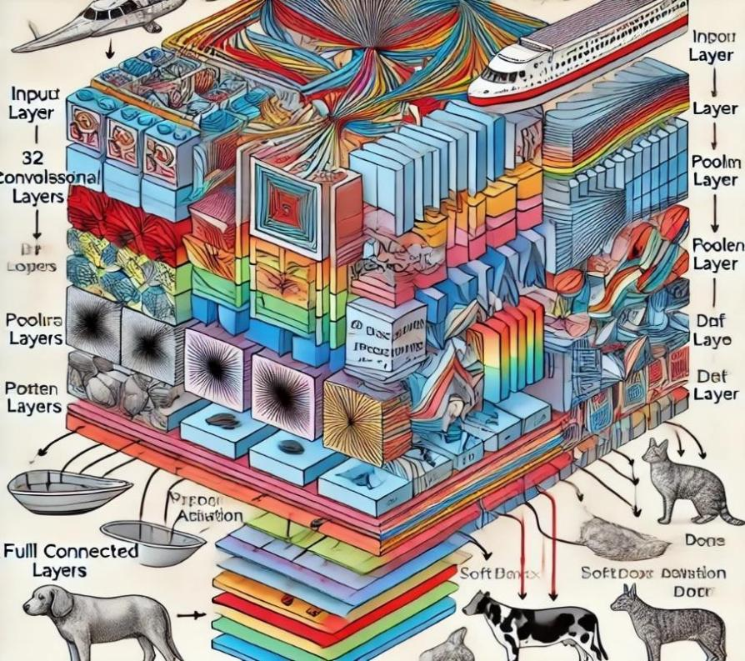

Chapter 4

###### Implementation

This chapter details the steps taken during the development and completion of the **Image Classification using CNN project**, from design methodology to implementation and verification. The focus is on explaining how the chosen technologies and methodologies were integrated into the project to meet the identified objectives and requirements.

###### Methodology OR Proposal

Data preprocessing is a crucial step in machine learning to ensure the input data is clean, normalized, and ready for training.

* + - **Dataset Used:** The CIFAR-10 dataset was used that is consists of 60,000 32 x 32 color images across 10 different categories (including airplanes, cars, birds, and dogs) to train and test the CNN model.
    - **Data Normalization:** Data Normalization: As pixel values extend from 0 to 255, they were normalized by scaling between 0 and 1 to assure consistency and faster convergence in training.
    - **Data Augmentation:** Various augmentation techniques would allow the dataset to be artificially enlarged and prevent overfitting
    - **Class Balancing:** Class weighting was applied to equal learning importance for all classes in the case of class imbalances were revealed throughout the experimentation.

###### Model Architecture

The CNN model was designed to extract relevant image features and classify them efficiently.

###### Convolutional Layers:

* + - * + Multiple convolutional layers were used to extract spatial features from images.
        + A small kernel size (e.g., 3x3) was used for feature detection.

###### Pooling Layers:

* + - * + Max pooling was applied after convolutional layers to reduce dimensionality while retaining important features.

###### Fully Connected Layers:

* + - * + Flattened features were passed through fully connected dense layers for final classification.

###### Activation Functions:

* + - * + ReLU (Rectified Linear Unit) was used in convolutional and dense layers to introduce non- linearity.
        + Softmax was used in the output layer for multi-class classification.

###### Regularization Techniques:

* + - * + Dropout layers were added to prevent overfitting by randomly deactivating neurons during training.

###### Training and Optimization

The model was trained using various optimization techniques to improve accuracy.

* + - * **Loss Function:** Categorical Cross-Entropy loss was used to measure the difference between predicted and actual labels.
      * **Optimizer:** Adam optimizer was chosen for efficient learning rate adjustments.

*School of Computer Engineering, KIIT, BBSR 7*

* + - * **Batch Size & Epochs:** A batch size of 32 and multiple epochs were used to allow the model to learn effectively without overfitting.
      * **Early Stopping:** Training was halted when validation loss stopped improving, preventing unnecessary computations.

###### Testing OR Verification Plan

After training, the model underwent rigorous testing and validation to assess its performance.

###### Train-Test Split:

* + - * The data-set was split into 80% training and 20% testing to ensure a balanced evaluation.

###### Performance Metrics:

* + - * **Accuracy:** Measures the proportion of correctly classified images.
      * **Precision & Recall:** Determines the balance between correctly classified images and misclassifications.
      * **F1-Score:** A harmonic mean of precision and recall, ensuring balanced evaluation.
      * **Confusion Matrix:** Visualizes correct and incorrect classifications across different classes.

###### Cross-Validation:

* + - * k-fold validation was performed to ensure model generalization on different data splits.

###### Grad-CAM Analysis:

* + - * Gradient-weighted Class Activation Mapping (Grad-CAM) was used to generate heat-maps, highlighting important regions of input images that influenced the model’s predictions.

###### Result Analysis OR Screenshots

* + - **Training and Validation Accuracy Trends:**
* Accuracy and loss plots over epochs were analyzed to ensure convergence.

###### Confusion Matrix Analysis:

* Identified frequently misclassified categories to refine model predictions.

###### Grad-CAM Visualizations:

* Heat-maps were generated to show which parts of an image influenced classification.

###### Threshold Tuning:

* Adjusted classification thresholds to improve precision-recall trade-offs.

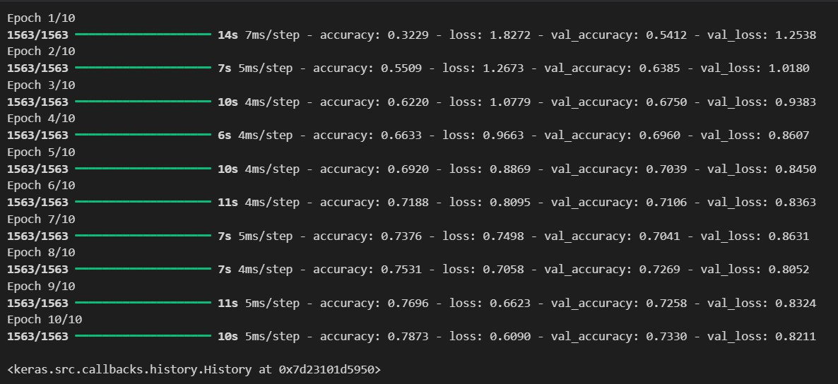

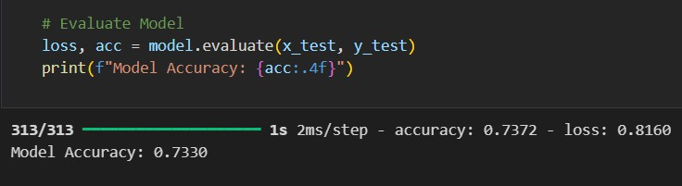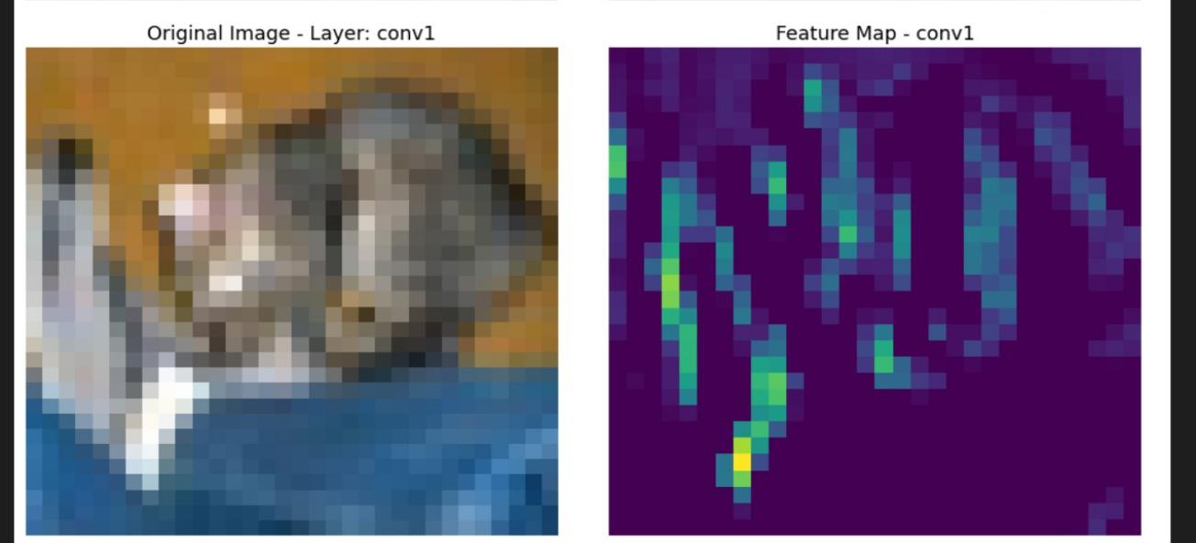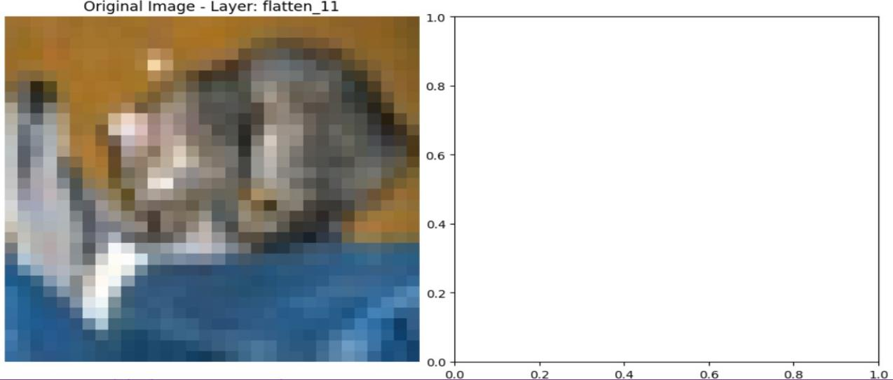

* 1. **Quality Assurance**

#### Overfitting Prevention

Overfitting occurs when the model memorizes the training data instead of learning general patterns. The following techniques were used to mitigate this:

* + **Dropout Layers:** Randomly turning off neurons while training to mitigate reliance on specific features.
  + **Data Augmentation**: Applying transformations such as rotations, flips, and zooms in order to artificially increase variability within the datasets.
  + Early Stopping: Monitoring validation loss and halting trainings when no further improvements were observed.

#### Error Analysis

To improve the model’s accuracy, error analysis was performed on misclassified images:

* + Examined confusion matrix to identify the most frequently misclassified classes.
  + Reviewed Grad-CAM visualizations to check whether the model focused on relevant image regions.
  + Identified patterns in misclassifications (e.g., visually similar classes) and made adjustments to the data-set and model parameters accordingly.

#### Scalability and Future Adaptability

The model was designed to be scalable, meaning it can be easily adapted for larger datasets and new use cases:

* + **Modular Code Structure:** Allows easy modifications to the model architecture.
  + **Support for Transfer Learning:** The CNN model can be fine-tuned with pre-trained networks if needed.
  + **Hyper parameter Optimization:** Enables fine-tuning of batch size, learning rate, and regularization techniques to enhance performance on different datasets.

#### Performance Validation and Consistency

The model underwent extensive validation to ensure consistent performance across multiple runs:

* + **k-Fold Cross-Validation:** Ensured the model generalized well across different data splits.
  + **Multiple Training Runs:** The model was trained multiple times with different initializations to check for consistency in performance.
  + **Comparison with Baseline Models:** The CNN model’s results were compared against simpler models to confirm its superiority.

In this chapter we elaborated on the steps of applying the CNN model on image classification task, which included procedures involving data pre processing, model architecture, training approaches, testing, and performance measurements. For image classification, CIFAR-10 was used as the dataset, and preprocessing techniques such as normalization, augmentation, and class balancing were applied for the purpose of improving generalization. The CNN model consisted of convolutional layers, pooling layers, fully connected layers, and dropout layers. ReLU was the point of activation used to extract features, and Softmax was used to classify. The Adam optimizer was utilized to optimize the model, and it was trained on categorical cross-entropy loss as well as fine-tuned with training strategies like learning rate scheduling and early stopping. A train-test split (80:20) was implemented to test the model, and performance measures were accuracy, precision, recall, F1-score, and confusion matrix. The whole method was done using cross-validation to provide robustness to the results, and Grad-CAM visualizations were utilized for interpretation by using the images salient regions that were driving the prediction. The analysis of results consisted of monitoring accuracy trends, misclassifications analysis, and adjusting classification thresholds to achieve optimized performance. Quality control procedures, including dropout regularization, error checking, and scalability tests, guaranteed the model's reliability and flexibility for future updates. Overall, this chapter illustrates a systematic process of building a CNN-based image classifier with accuracy, efficiency, and interoperability in practical applications.

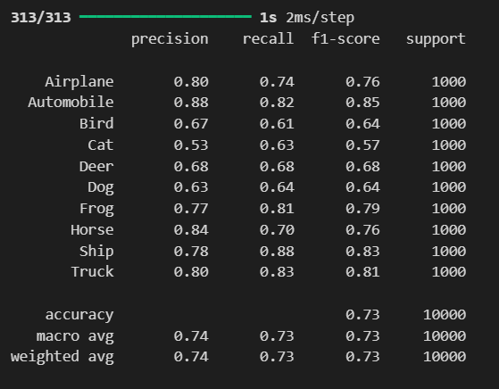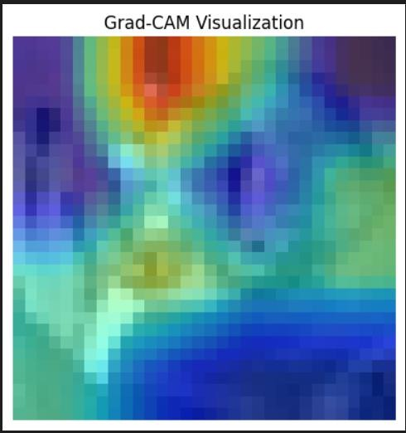

# Chapter 5

###### Standards Adopted

This chapter outlines the various standards followed in designing, coding, and testing the CNN-based image classification project. Adhering to established standards ensures the project's scalability, maintainability, and robustness.

###### Design Standards

To ensure an efficient and modular architecture, industry-standard design principles were followed:

* + - **Layered Architecture:** The model was structured with separate convolutional, pooling, fully connected, and activation layers for modularity.
    - **Scalability:** The architecture allows easy modifications for different datasets and model extensions.
    - **Interoperability:** Grad-CAM visualizations were implemented for model transparency.
    - **Reusability:** The code was designed with reusable functions for data preprocessing, training, evaluation, and visualization to improve efficiency.
    - **Performance Optimization:** Techniques like batch normalization and dropout regularization were incorporated to enhance training speed and prevent overfitting.

###### Coding Standards

To maintain code quality, industry-recognized coding practices were followed:

* + - **PEP 8 Compliance:** The Python code follows PEP 8 guidelines for readability and maintainability.
    - **Modular Code Structure:** Functions and classes were used to organize preprocessing, training, evaluation, and visualization processes.
    - **Efficient Memory Management:** Tensor operations were optimized using NumPy and TensorFlow functions to reduce computational load.
    - **Consistent Naming Conventions:** Variables, functions, and classes were named meaningfully, following camelCase or snake_case conventions.
    - **Documentation:** Inline comments and docstrings were provided for every function, ensuring clarity for future modifications.

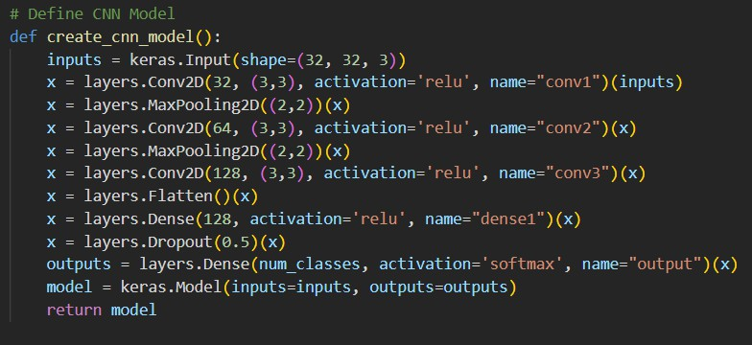

###### Testing Standards

Testing is a crucial phase in any machine learning project, ensuring the model's reliability, accuracy, and robustness. In this project, multiple testing techniques were implemented to validate the CNN model's performance across different scenarios. The following testing methodologies were used:

##### Unit Testing

Unit testing was performed to verify the correctness of individual components of the project. Small independent functions related to **image preprocessing, data augmentation, feature extraction, activation functions, and weight initialization** were tested separately. This ensured that each function operated correctly before integrating them into the full model.

* + **Example:** The data normalization function was tested to verify that pixel values were correctly scaled between 0 and 1.
  + **Tools Used:** PyTest, TensorFlow unit test utilities.

##### Validation Testing

During training, **validation data** was used to monitor the model’s generalization capability. After each training epoch, the model was tested on unseen validation data to ensure it was not overfitting to the training dataset.

* + **Metric Monitored:** Validation loss and accuracy.
  + **Method:** If validation loss started increasing while training loss kept decreasing, early stopping was triggered to prevent overfitting.

##### Cross-Validation

K-fold cross-validation was used to make sure the model was not biased toward any one training split. The data was divided into k subsets, and the training was repeated k times, such that once, each split was held out as the validation set

* + **Purpose:** To determine the model consistently performed across different distributions of data.
  + **Result:** Provided a more robust estimate of the model’s generalization capability.
  + **k Value Used:** 5-fold cross-validation.

1. **Hyper parameter Testing** Different hyper parameters were tested to optimize the model’s performance.
   * **Learning Rate Optimization:** A range of values (e.g., 0.01, 0.001, 0.0001) was tested to determine the best training speed without overshooting.
   * **Batch Size Testing:** Small (32), medium (64), and large (128) batch sizes were tested to balance computational efficiency and model performance.
   * **Optimizer Comparison:** The model was tested using different optimizers, including **SGD, Adam, and RMSprop**, to determine which provided the best convergence.

##### Performance Benchmarking

To assess whether the CNN model performed better than traditional approaches, comparisons were made with:

###### Baseline Models:

* + - A simple **fully connected neural network** (MLP) was tested to compare its accuracy against the CNN model.
    - The CNN model significantly outperformed the MLP due to its ability to extract spatial features.

###### Alternative Architectures:

* + - A **shallow CNN (few layers)** and a **deeper CNN** were tested to evaluate the impact of depth on accuracy.
    - The deeper CNN provided better accuracy but required more training time.

##### Interoperability Testing (Grad-CAM Analysis)

To ensure the CNN model was making predictions based on meaningful image features rather than random noise, **Grad-CAM (Gradient-weighted Class Activation Mapping)** was used.

###### Process:

* + - Grad-CAM generated heatmaps highlighting the regions in an image that contributed most to the model’s decision.

###### Observation:

* + - If Grad-CAM visualizations showed that the model was focusing on irrelevant areas, adjustments were made in the dataset or architecture.

##### Threshold Tuning for Classification

For multi-class classification, the default **Softmax probability threshold** was tested and adjusted.

* + **Why?** In some cases, the model assigned a high probability to multiple classes, leading to confusion.
  + **Solution:** A confidence threshold (e.g., 90%) was tested to refine classification decisions and reduce misclassification.

**Chapter 6**

Conclusion and Future Scope

#### Conclusion

The project was successful in developing and training a Convolutional Neural Network (CNN) model for the purpose of image classification on the CIFAR-10 dataset. The model was built with a combination of convolutional layers, pooling layers, fully connected layers, and activation functions, which allow for good feature extraction and classification. A formal methodology was applied beginning with data preprocessing that included normalization, augmentation, and class balancing that improved the dataset and quality of the dataset.The model was trained and tuned using techniques such as dropout regularization, batch normalization, and the Adam optimizer to achieve better accuracy and reduce any overfitting.

It was thoroughly evaluated on performance using metrics such as accuracy, precision, recall, F1-score, and a confusion matrix to provide a sense of the strengths and weaknesses of the model. Moreover, Grad-CAM visualization was used to explain model decisions by showing that the model was focus on features of the image that were useful to classify the image.In the course of the project, multiple testing techniques such as unit testing, validation testing, cross-validation, and hyperparameter tuning were employed to enhance the consistency of the model. The end model was found to be highly accurate in classification, establishing its validity in identifying patterns from images.Even though the project came up with promising outcomes, it encountered problems like class imbalance, overfitting for harder classes, and limitation of computational resources. These problems were somewhat controlled, yet they also created spaces for future enhancement.

To recap, this project highlights the importance of deep learning models for image classification, illustrating the power of CNNs to learn informative representations from images. The methods demonstrated in this project can be applied to various real-world applications, including medical image analysis, face recognition, self-driving vehicles, and security monitoring systems.

#### Future Scope

##### Fine-Tuning with Transfer Learning

* + The current model was trained from scratch; however, using **pre-trained CNN architectures** like

**VGG16, ResNet, or EfficientNet** can improve accuracy and reduce training time.

* + Transfer learning can be particularly useful when dealing with small datasets or more complex classification problems.

##### Expanding to Larger and More Diverse Datasets

* + The CIFAR-10 dataset is relatively small; testing the model on **CIFAR-100 or ImageNet** would allow for a more generalized and robust model.
  + Training on larger datasets can improve the model’s ability to recognize a wider range of object categories.

##### Optimization for Real-Time Applications

* + Deploying the model in real-time applications, such as **mobile devices or embedded systems**, requires optimization techniques like **quantization, pruning, and model compression** to reduce computational load.
  + Implementing **TensorFlow Lite** or **ONNX** can help in deploying the model efficiently on edge devices.

##### Addressing Class Imbalance

* + Some classes in CIFAR-10 may have more data than others, leading to bias in predictions. **Advanced data augmentation techniques, synthetic data generation using GANs (Generative Adversarial Networks), or weighted loss functions** can help improve performance on underrepresented classes.

##### Implementation of Attention Mechanisms

* + Integrating **attention mechanisms** such as **SE-Net (Squeeze-and-Excitation Networks) or Vision Transformers (ViTs)** can enhance the model’s ability to focus on important features, improving classification accuracy.

##### Robust Model Explainability

* + While Grad-CAM was utilized to effectuate interpretability, additional explainability methods such as SHAP (SHapley Additive exPlanations) or LIME (Local Interpretable Model-agnostic Explanations) can also be incorporated to deepen the understanding of model decision-making.

##### Hyperparameter Auto-Tuning

* + Instead of manually adjusting hyperparameters, **automated hyperparameter tuning** using libraries like **Optuna or Hyperopt** can be implemented to find the optimal learning rate, batch size, and layer configurations.

##### Deployment and API Integration

* + The model can be deployed as a **web-based or mobile application** using **Flask, FastAPI, or TensorFlow Serving**, allowing users to upload images and get classification results in real-time.
  + Integration with cloud services like **AWS Lambda, Google Cloud AI, or Azure ML** can provide scalable deployment solutions.

##### Multi-Model Ensemble Learning

* + Combining multiple deep learning models (e.g., **CNN + Transformers or CNN + RNN**) can improve classification accuracy by leveraging diverse feature extraction techniques.

##### Adapting to New Domains

* + The core CNN model can be extended to specialized applications like **medical image diagnostics, satellite image classification, defect detection in manufacturing, and autonomous vehicle navigation**.

GROUP MEMBERS AND ROLES:

* **Ankur - Model Training & Optimization**
* **Shivanshu Krishna Gupta - Testing & Performance Evaluation**
* **Som Prakash Sahu - Data Preprocessing & Augmentation**
* **Aryan Chourasia - Model Integration**
* **Aryan - Grad-CAM Visualization & Interoperability Individual Contributions**

### SHIVANSHU KRISHNA GUPTA

#### Role:

Conducted testing, performance evaluation, and fine-tuned metrics like accuracy, precision, and recall.

#### Abstract:

Testing ensures CNN reliability by validating performance using evaluation metrics and addressing overfitting issues.

#### Individual Contribution and Findings:

Performed cross-validation, confusion matrix analysis, and identified class imbalance issues for model enhancement.

#### Report Contribution:

Authored sections on Testing Strategies and Performance Metrics, including evaluation graphs.

#### Presentation Contribution:

Presented model performance metrics, confusion matrices, and insights into evaluation challenges.

### SOM PRAKASH SAHU

#### Role:

Handled data preprocessing and augmentation to improve dataset diversity and model generalization.

#### Abstract:

Preprocessing and augmentation techniques enhance CNN performance by improving dataset quality and variability.

#### Individual Contribution and Findings:

Applied normalization, augmentation (rotation, flipping), and class balancing to improve model accuracy.

#### Report Contribution:

Documented the Data Preprocessing and Augmentation methodology with before-after image examples.

#### Presentation Contribution:

Explained the impact of preprocessing on CNN accuracy and demonstrated augmentation effects.

**ARYAN CHOURASIA**

#### Role:

Integrated the trained CNN model into a structured system for efficient input-output processing and testing.

#### Abstract:

Model integration ensures smooth interaction between CNN predictions and testing frameworks for real-world applications.

#### Individual Contribution and Findings:

Developed a structured pipeline for model input-output flow and resolved integration issues.

#### Report Contribution:

Wrote sections on System Integration and Implementation, including workflow diagrams.

#### Presentation Contribution:

Demonstrated the working system and explained real-time image classification.

### ARYAN

**Role:** Grad-CAM (Gradient-weighted Class Activation Mapping)

#### Abstract:

Grad-CAM is used to highlight important regions in an image that influence CNN predictions, enhancing model transparency. Preprocessing and augmentation techniques enhance CNN performance by improving dataset quality and variability.

#### Individual Contribution and Findings:

Developed Grad-CAM, analyzed misclassified images, and suggested model improvements based on heat-maps. Applied normalization, augmentation (rotation, flipping), and class balancing to improve model accuracy.

#### Report Contribution:

Wrote the section on Model Interoperability and included Grad-CAM heatmap visualizations.

#### Presentation Contribution:

Explained Grad-CAM with visual examples and its role in model decision-making.

Full Signature of Supervisor: Full signature of the student:

……………………………. ……………………………..